**Introduction of CSV file uploading App:-**This app is similar to sendgrid contact submenu in market campaigns menu. There are two modules in it.First module is uploading a csv file and second module is download results in csv format.

**Upload Module(Upload a file ,Show csv headers,database headers and add to database):-**It provides us facility to upload a csvfiles.When user upload a csv file by clicking upload button,there are csv file columns of csv file are shown on left side and combo lists are shown on right side on screen. Csv file columns matches with database table columns.If the csvheaderscolumns of csv file are matched with database columns then it show a dropdown option with checkbox else it show a dropdown with option add field.User can add csv file headers and add to database.In database the selected columns of a csv file is added to database table columns.Users can also use the concept of mapping.For example:-If user want to add customer name field to first name then he can do it with mapping and save customer name value in first name field.

**Download Module(Search the results and export it ):-**Users can search their contacts according to their ages and gender option.

**There are three conditions in it:-**

1)User can select age and does not select the gender option and search contacts according to selected age.For example:-User Selects between 20-40 age in dropdown menu then the all contacts are shown according to 20-40 age.

2)User can select gender option and does not select the age option and click the search button.The data is shown according to their gender.

3)User can select gender option and select the age option and click the search button.The data is shown according to their gender and age.

After that,The data is retrieved from the database can be download in csv format by click export button.

**Technology Used:-**There are front end technology and backend technology used for creating an app.

**Front-End Technology:-** PHP, bootstrap, jquery

**Backend Technology:-**Mysql,Mysqli­­­­­

**Front-end Design:-**BY using php, bootstrap and jquery I have created a design of app.

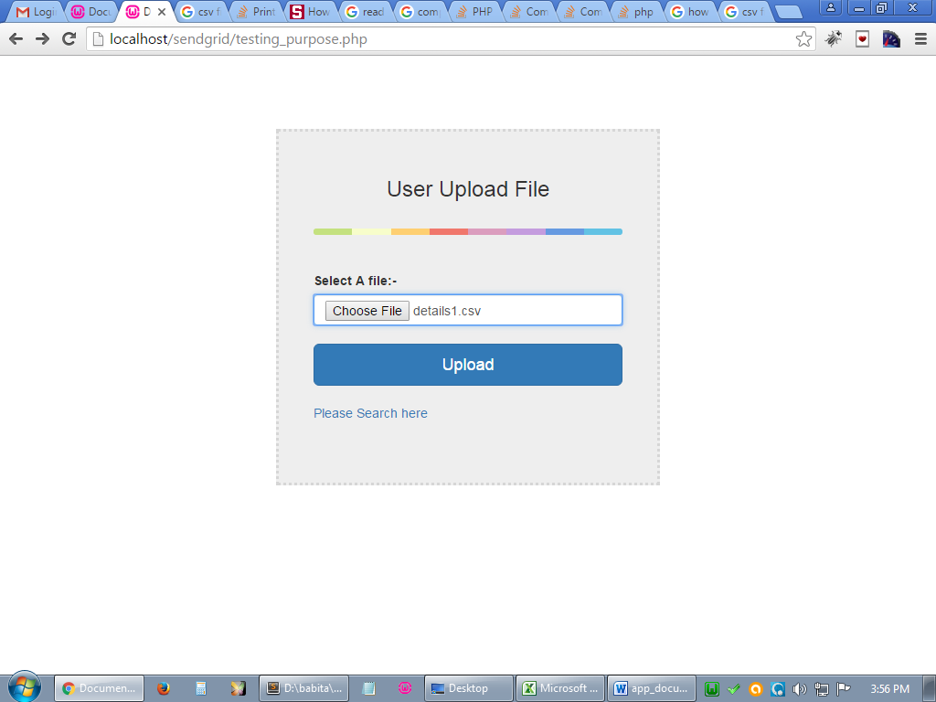

**Backend Tables Used:-**There is only one table user used in phpmyadmin.

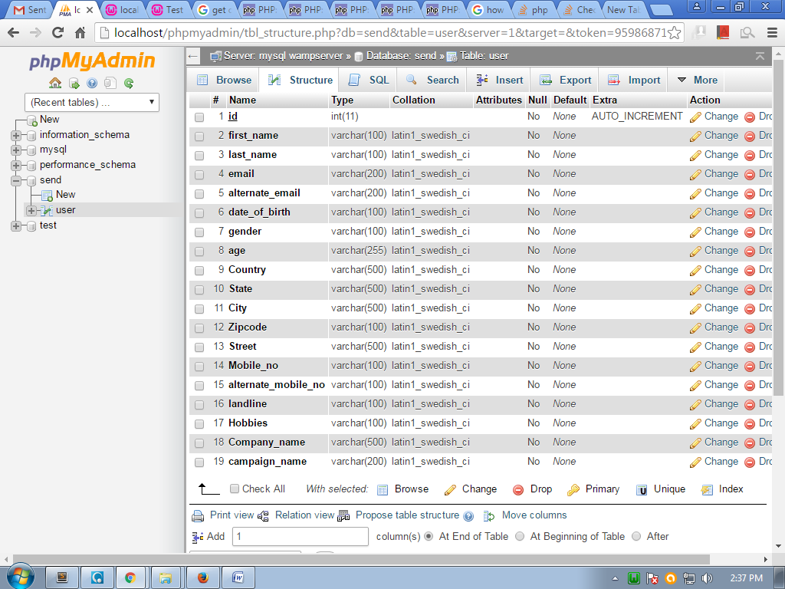

**Working of an app:-**Here is a logic of uploading a csv file and add to database.First of all, design of an app by using bootstrap,use of bootstrap classes and bootstrap form of uploading a file.

**Here is coding part**

The file upload is required if user don’t upload a file it gives an alert that please select a file.

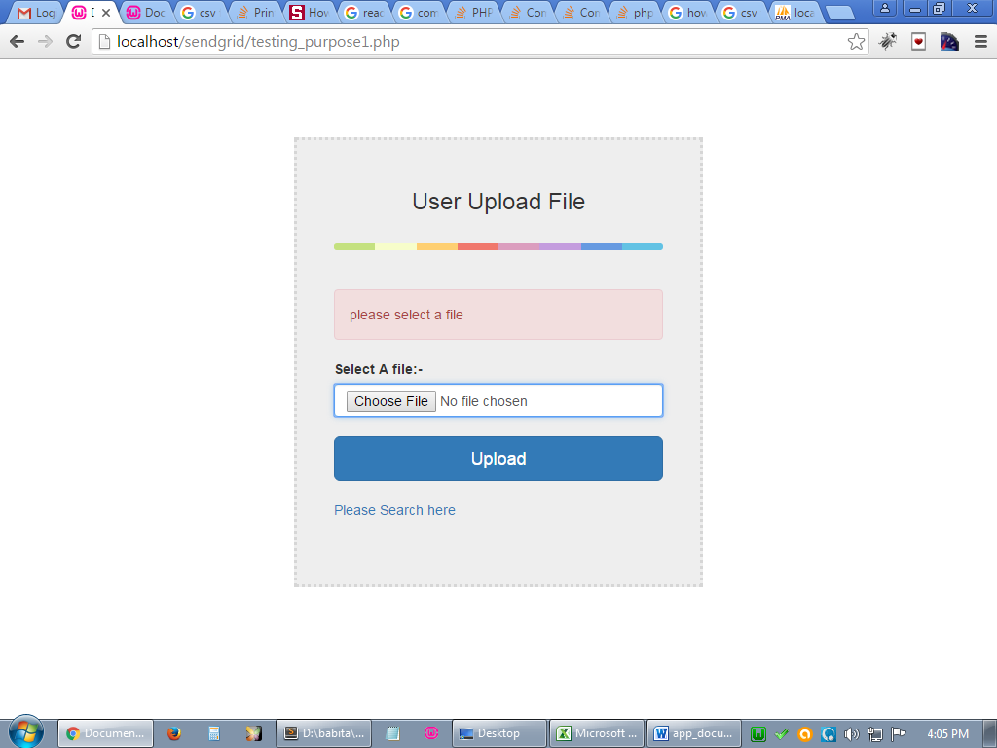

If someone upload a word file its gives error like please upload a file in csv file format.

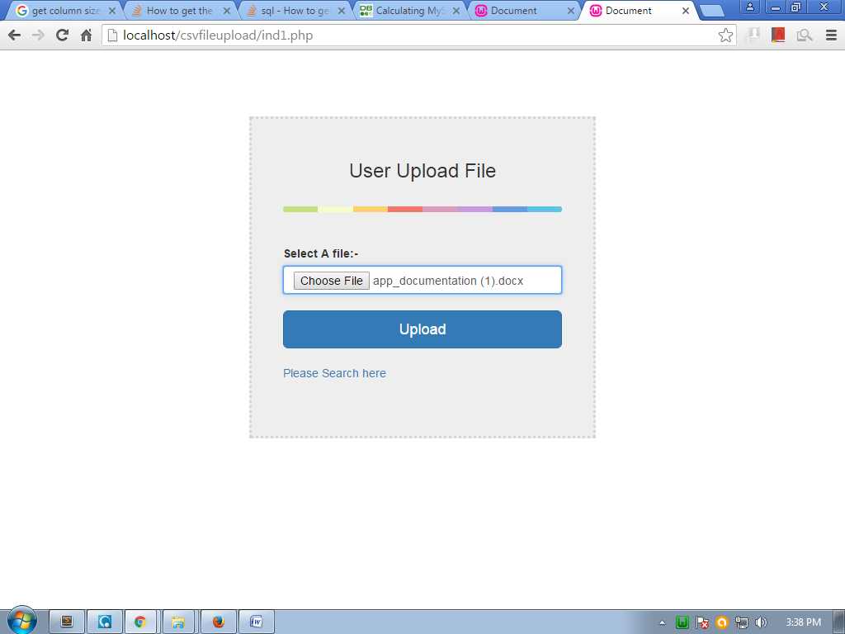

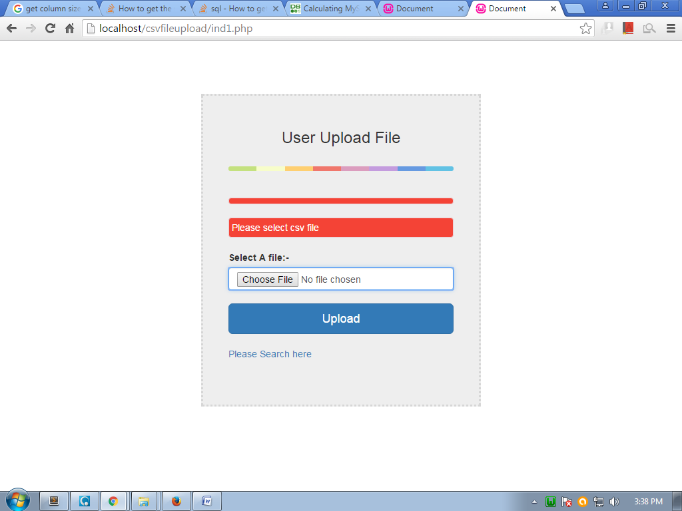

When user upload a csv file by clicking upload button,the csv file columns of csv file are shown on left side and combo lists are shown on right side on the screen.It matches the result with database table columns.If the csv headers columns of csv file are matched with database columns then it show a dropdown option else it show a dropdown with option add field or choose and there are database table columns in dropdown list.On left side there are csv file columns shown with red mark show that this field does not exists in database.

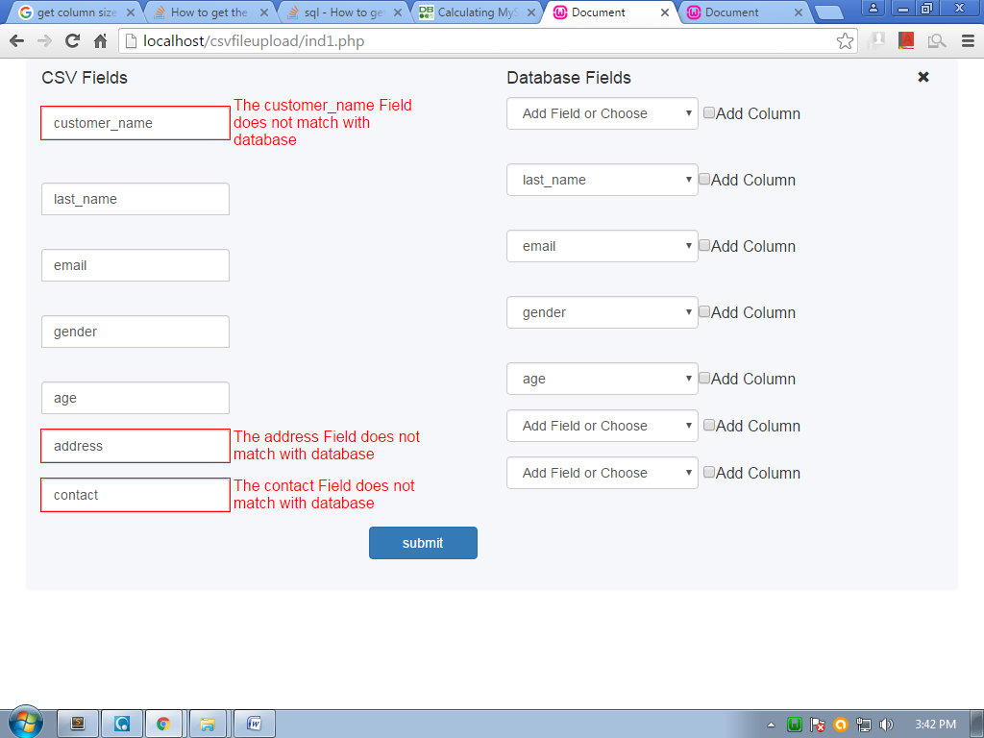

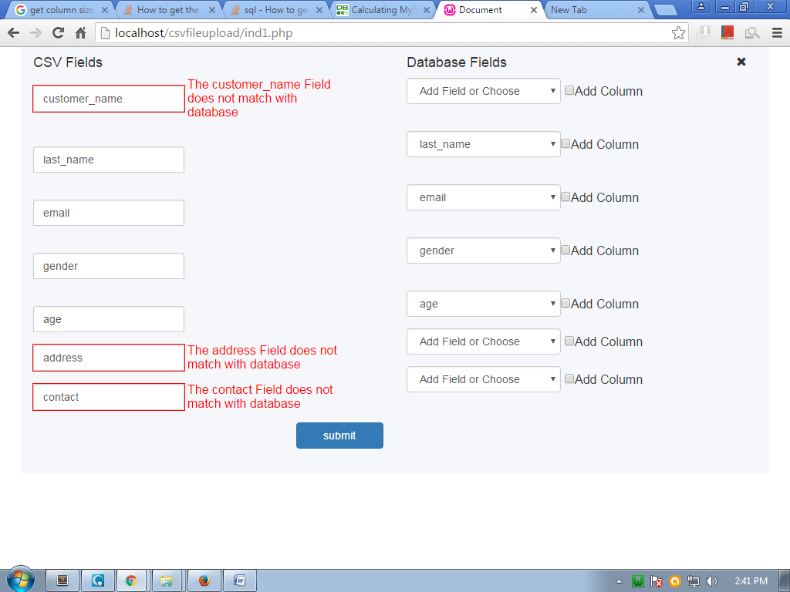

1)Users have option to choose a csv headers fields of a file and add it to the database.For Example If user select lastname,email and email in it.

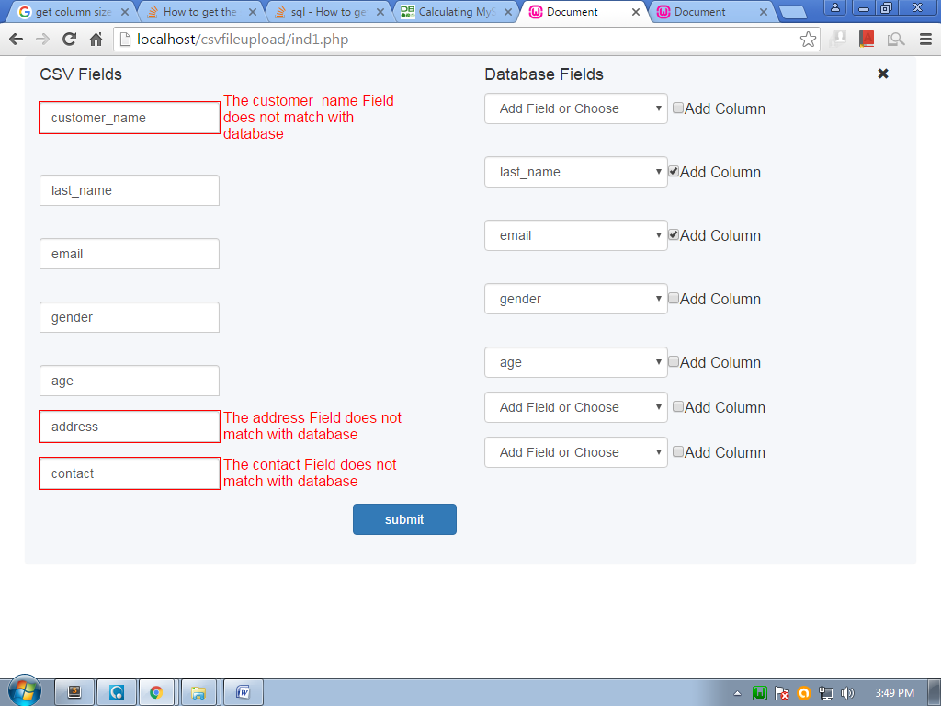

The selected column add to database.

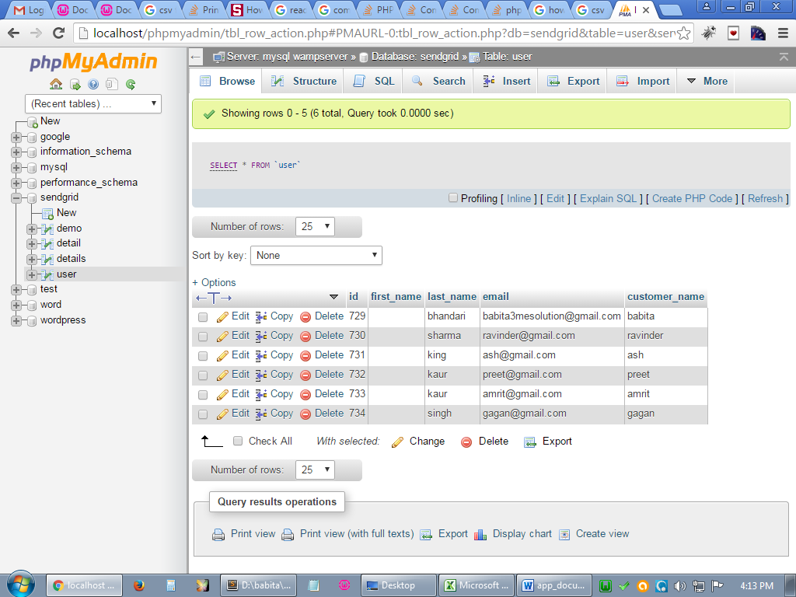

When user want to add the customer_name column of csv file which does not exist in database value then he have options in combo list either user choose add a field option or select database columns in options .

1)if user want to add customer_name to database then he choose add a field option in combolist.user choose add new field option from combolist then dynamic text is generated.

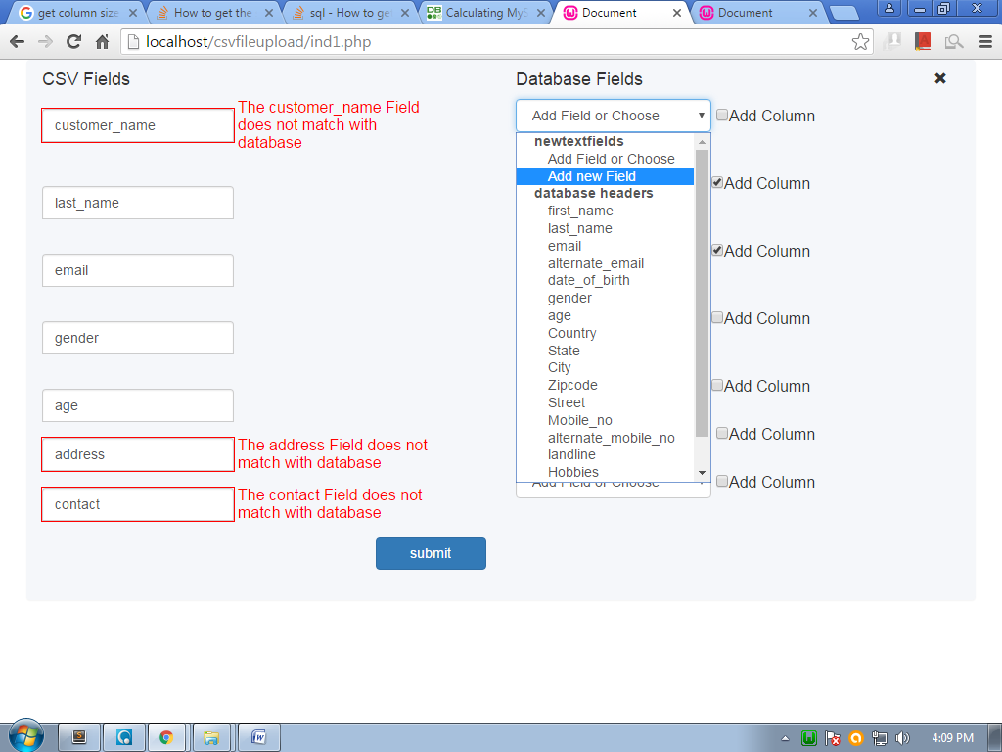

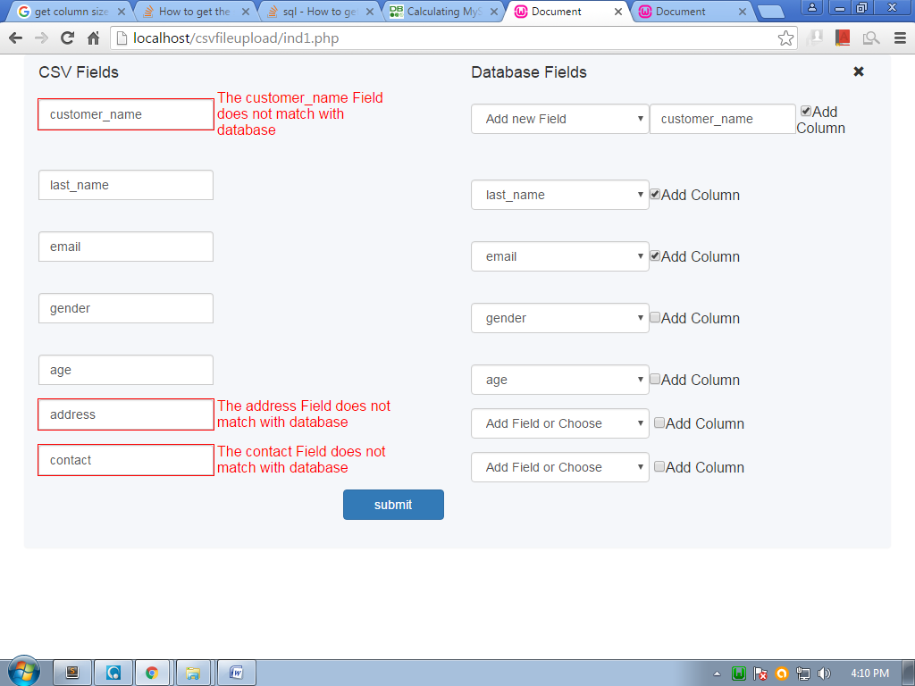

Now user can add the dynamic text generated textbox value to database.

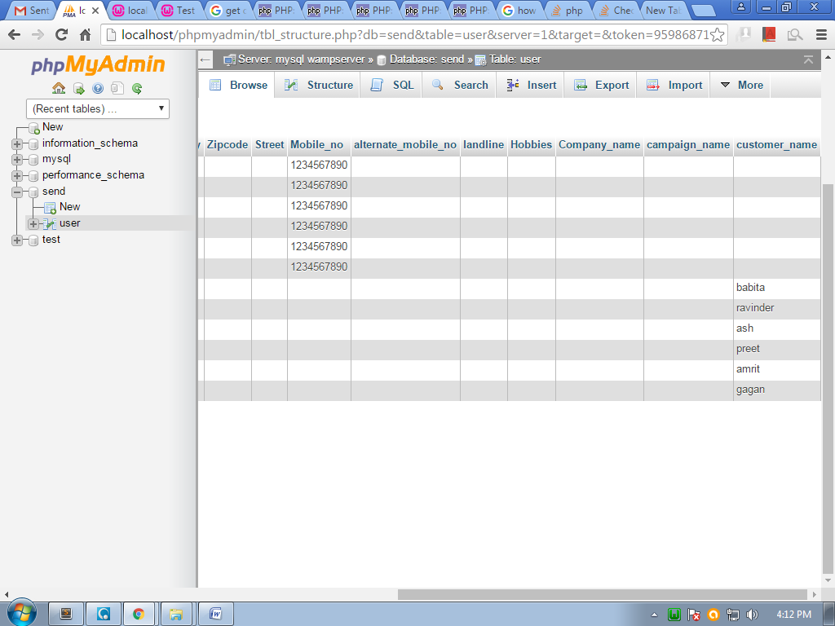

**Mapping:-**There is also a functionality of mapping.If user want to map a field then he can do it with mapping. **for example:-**If user want to map a customer name field to first name which is coming from database table columns then he can do it.

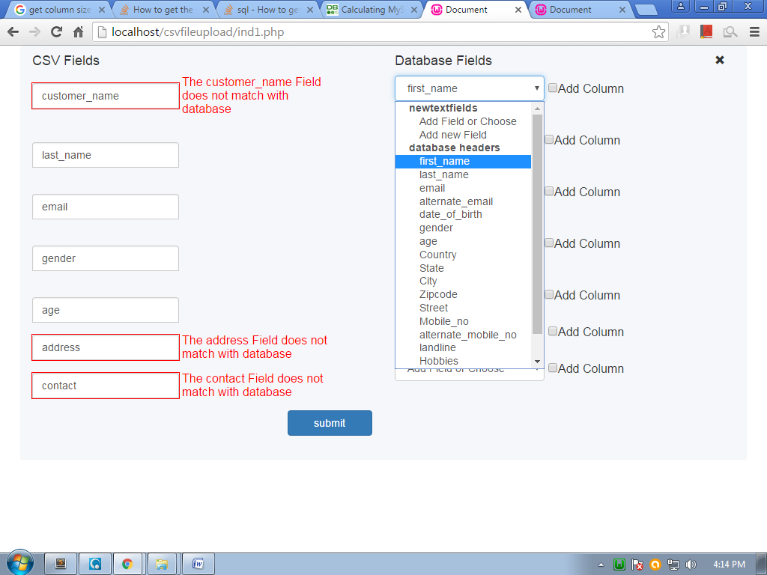

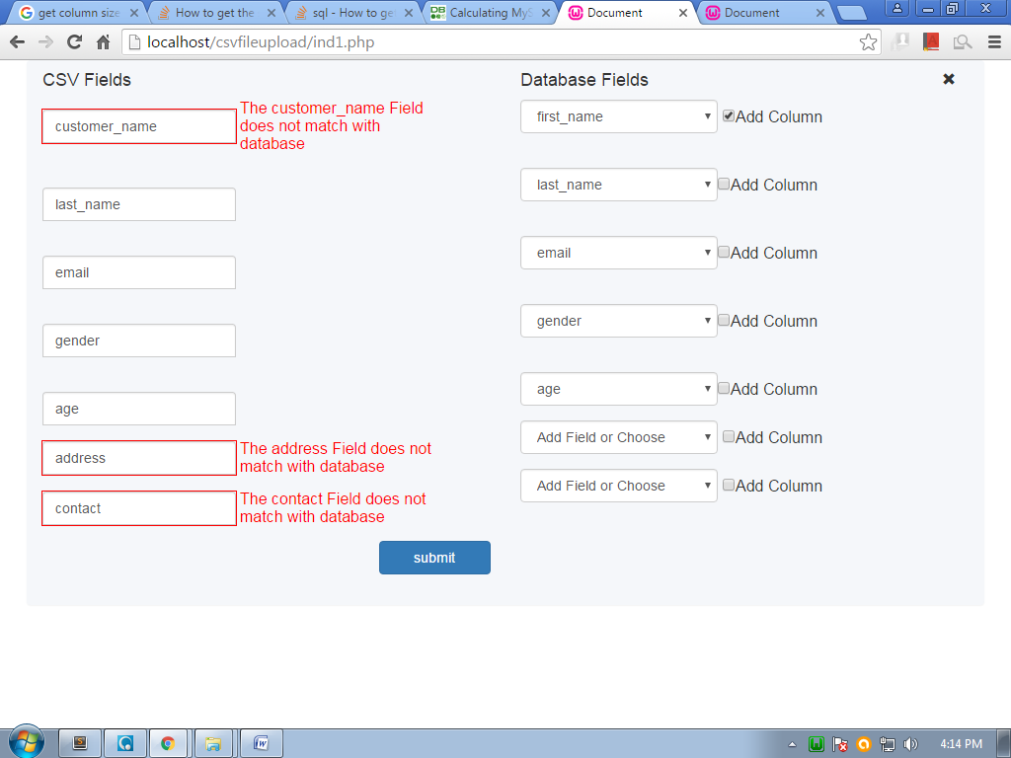

Now the user can add the customer name field map to first name.

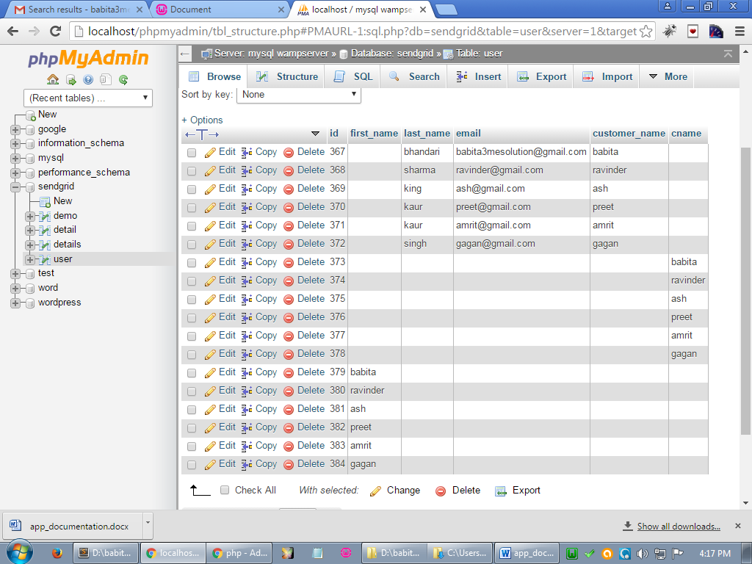

Now the user can retrieve the result according to selection.

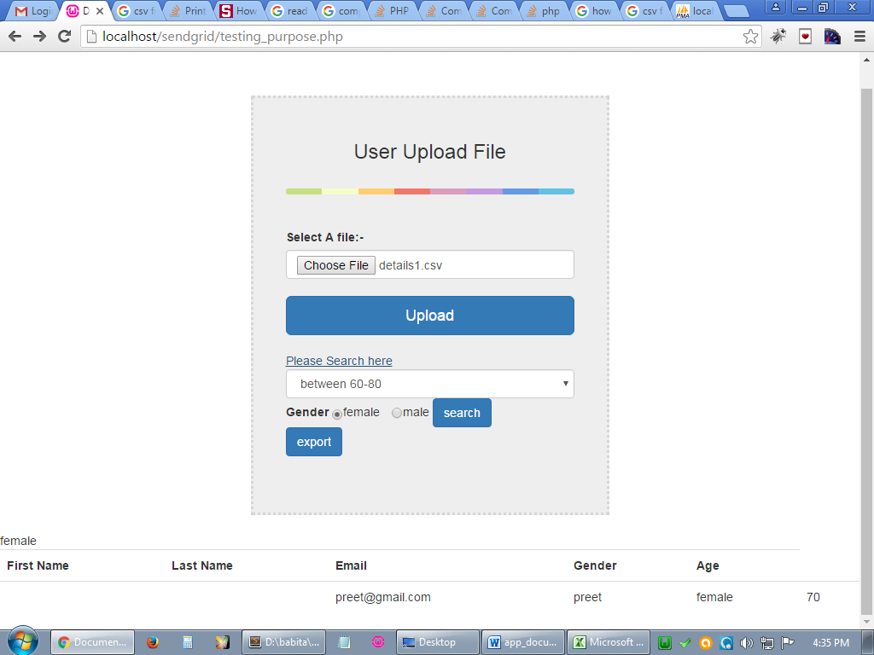

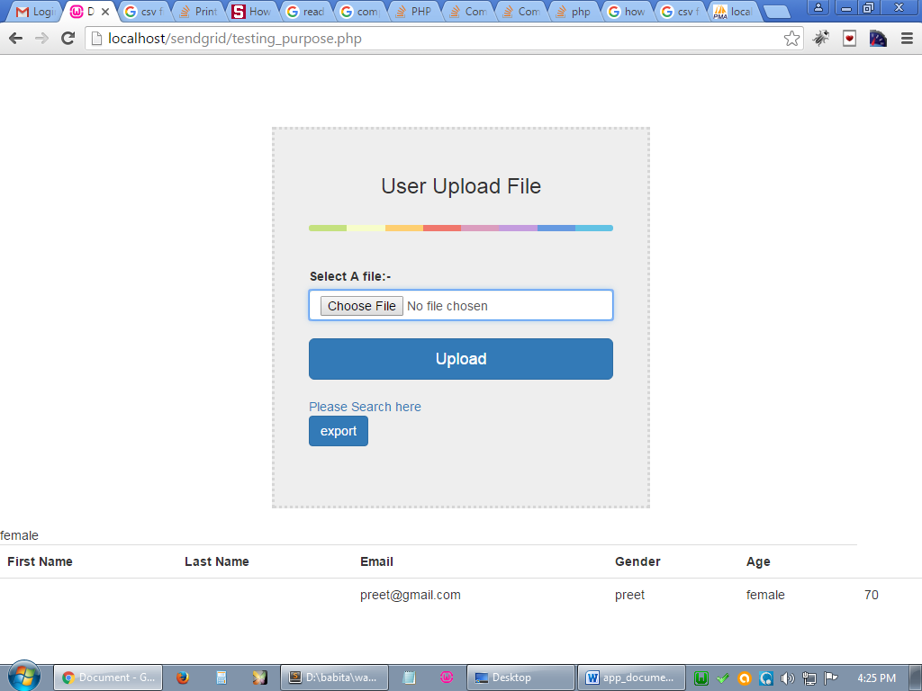

At last User can export the result by click on export button.The file is download in csv format.

